Dis-US-TN-Hales Point, Lauderdale County

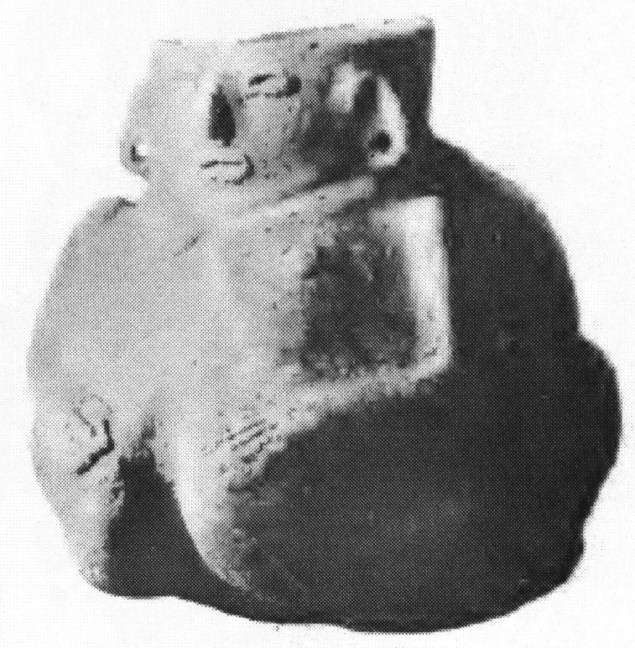 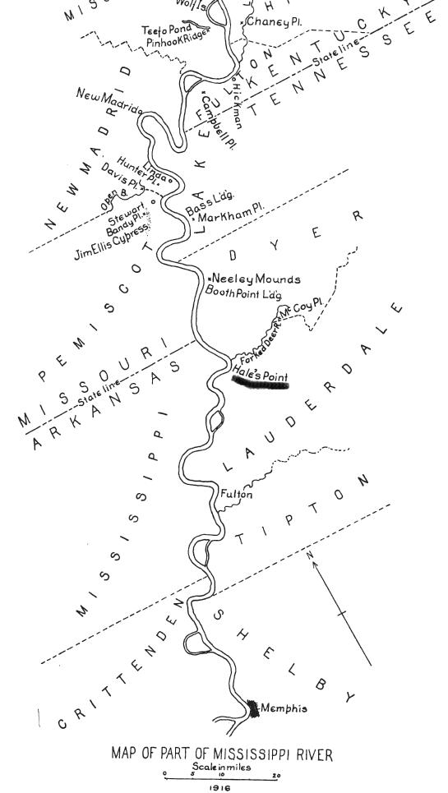

Left: Human effigy ceramic bottle 6.73 in. high, Middle Mississippian Period (A.D. 1200 – 1400) with "the face of the figure being in relief on the neck of the bottle" (Moore 1916, 496). Right: Map of Middle Mississippi area with Hale's Point underlined (after Moore 1916: 492).

Reference: Clarence B. Moore, Some aboriginal sites on Green River Kentucky (Philadelphia 1916), p. 496, Fig. 25.